Phase-2 Submission Template
Student Name: V Dharanish
Register Number: 732123104028
Institution: Nandha College Of Technology
Department:B.E.Computer Science And Engineering
Date of Submission:
Github Repository Link:

1. Problem Statement
Customer churn—when customers stop using a service or product—is a major concern for businesses. Retaining existing customers is often more cost-effective than acquiring new ones. This project aims to predict whether a customer is likely to churn, enabling proactive retention strategies.
- Type of Problem: Supervised Classification

2. Project Objectives
- • Primary Goal: Build a machine learning model that accurately predicts customer churn.
- • Technical Objectives:
- Clean and preprocess data for model readiness.
- Perform EDA to uncover trends and correlations.
- Engineer meaningful features to boost model performance.
- Train and evaluate multiple classification models.
- • Updated Goal Post EDA: Added emphasis on interpretability alongside accuracy to support business decision-making.

3. Flowchart of the Project Workflow
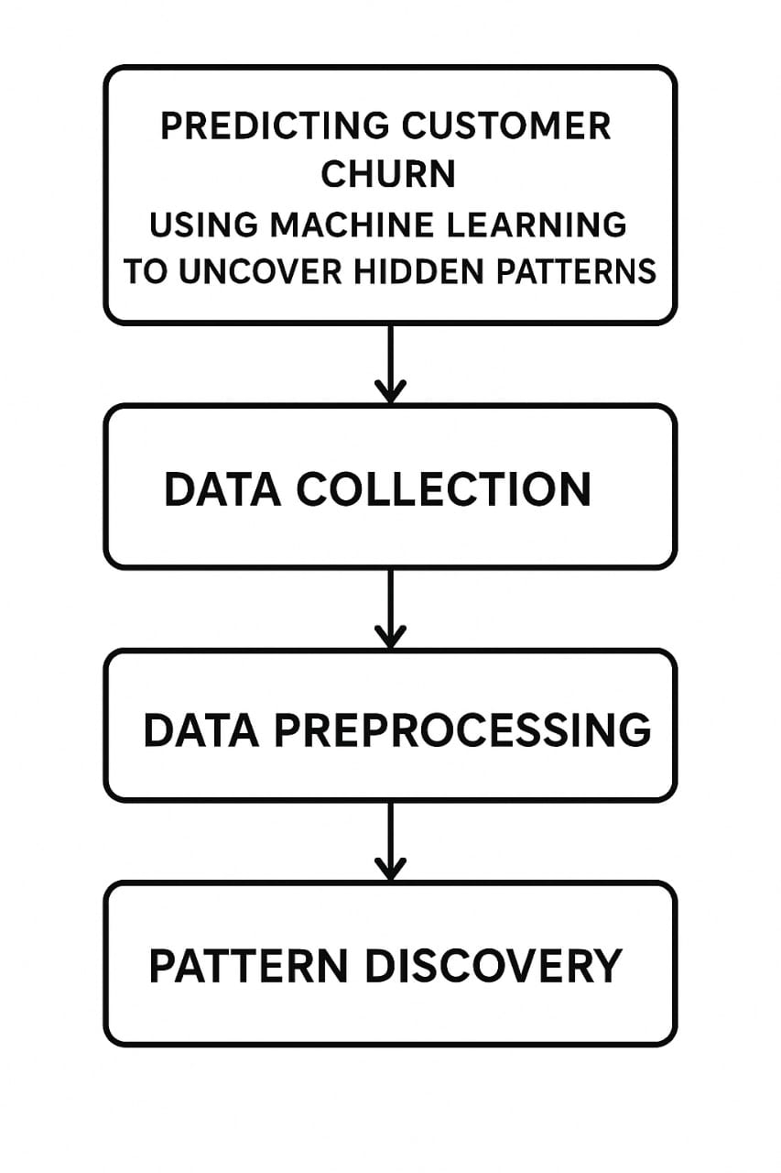
4. Data Description
• Dataset Name: Telco Customer Churn (Kaggle)

• Origin: Kaggle Dataset
• Data Type: Structured tabular data

• Records: ~7,000 customers

• Features: 21 features including demographic and service usage

• Static/Dynamic: Static

• Target Variable: Churn

5. Data Preprocessing
- • Missing Values: Handled missing TotalCharges by imputation (mean/median).
- • Duplicates: Checked and removed exact duplicates.
- • Outliers: Visualized with boxplots; capped or removed extreme cases.
- • Data Type Conversion: TotalCharges converted from object to float.
- • Categorical Encoding:
- Binary: Label Encoding
- Multi-class: One-Hot Encoding
- • Feature Scaling: StandardScaler used for numerical features.

6. Exploratory Data Analysis (EDA)
  - • Univariate:
  - Countplots for categorical variables (e.g., Contract type, Gender)
  - Histograms and boxplots for numerical variables (e.g., Tenure)
  - • Bivariate:
  - Churn vs Contract Type: High churn in month-to-month contracts
  - Churn vs Internet Service: Fiber optic users had higher churn
  - Correlation heatmap to find multicollinearity
  - • Insights:
  - Short tenure, monthly billing, and high charges are linked with churn.

7. Feature Engineering
- • New Features:
- Tenure buckets (0–12, 12–24, etc.)
- Average Monthly Spend = TotalCharges / Tenure
- • Transformations:
- Combined related features (e.g., TotalCharges and MonthlyCharges)
- • Dimensionality Reduction: PCA not used due to interpretability needs

8. Model Building
  - • Algorithms Used:
  - Logistic Regression: For baseline and interpretability
  - Random Forest: For non-linear relationships and feature importance

  - • Train-Test Split: 80-20 with stratification

  - • Performance Metrics:
  - Accuracy
  - Precision
  - Recall
  - F1-Score
  - ROC-AUC
  - • Initial Results:
Logistic Regression: Accuracy ~79%
Random Forest: Accuracy ~83%, ROC-AUC ~0.87

9. Visualization of Results & Model Insights

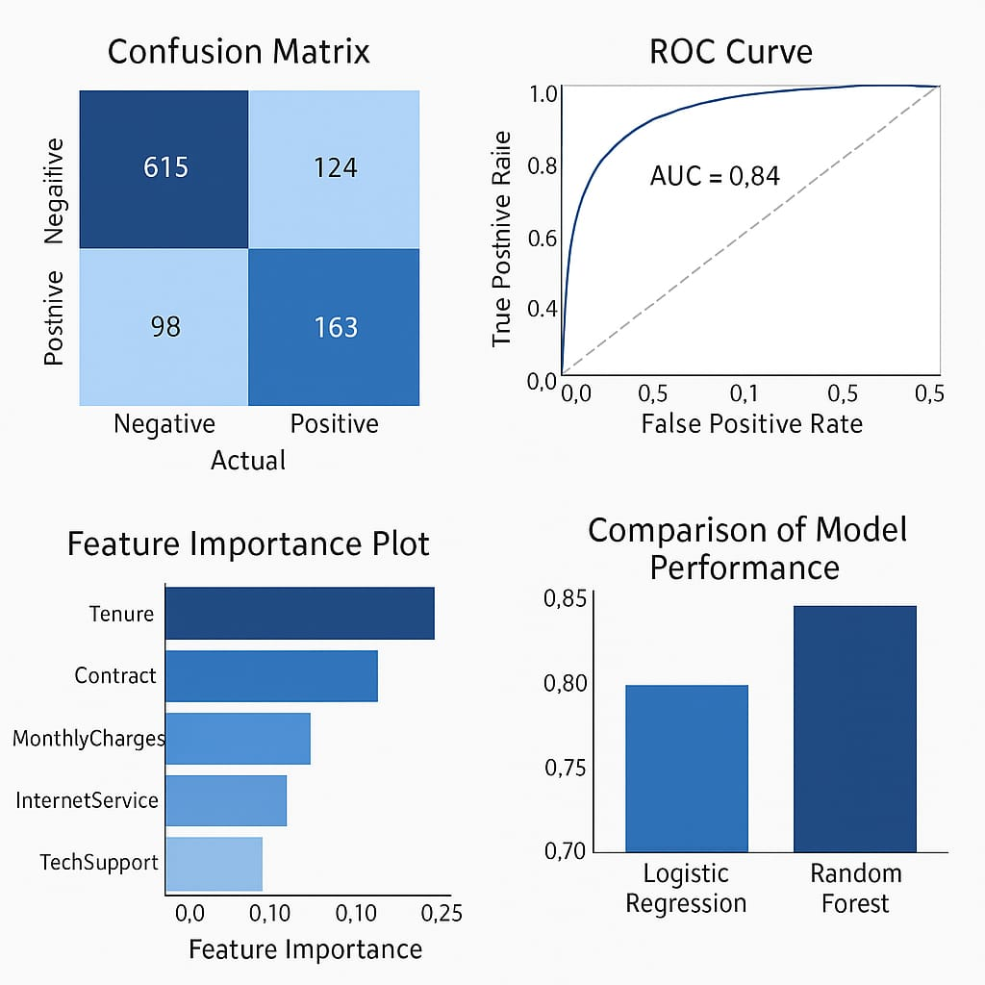

10. Tools and Technologies Used
- • Language: Python
- • Development environment: Google Colab
- • Libraries:
- Data: pandas, numpy
- Visualization: seaborn, matplotlib, plotly
- ML: scikit-learn, XGBoost
- • Optional Tools: Tableau (for dashboarding), Power BI

11. Team Members and Contributions
- V Dharanish : prepare the dataset and helps with data cleaning
- S Dharun kumar :Explores the data analysis (EDA) and feature engineer.
- S Chandru : prepare the documentation & reporting and model development

